**HCI ASSIGNMENT – 1**

Course No: CSE 4849

Members:

Fardin Saad (154419)

Md. Alamin Shaheen (154423)

Rahat Anwar Khan (154431)

Rafayat Ahmed (154436)

HCI Project: **Music Playback based on Emotion Recognition**

* A PSR description of our HCI project is given below:

Our HCI project is basically the creation of a music playback application which works on the underlying emotions of our users. Therefore by determining the emotions of our users the app will play different songs according to that.

**Methodology:**

We followed some structured techniques while collecting data from our potential users. The techniques are:

1. Unstructured Interviews
2. Focus Groups
3. Questionnaires
4. Statistics from Internet

Firstly, for collecting data we chose IUT and BRAC University in order to form a view of our potential users i.e. our persona. We conducted unstructured interviews individually regarding our app and gained wonderful insight from our potential users.

Secondly, we gathered a group of students in both BRAC and IUT and collected data by letting them participate in a group conversation regarding our app. They could put forward their opinions and views in a supportive environment conducted by us.

Thirdly, we also supervised a survey where we handed them a list of questions which contained questions about our app. Such as:

1. *Do you listen to music when you are feeling down?*
2. *What sort music you listen to while you are feeling down?*
3. *Does it help you feel better?*
4. *Would you use an app that would recommend you to listen music based on your emotion?*

Fourthly, we reviewed several statistics on the internet regarding the users’ age group for using different music playback applications.

Lastly, we conducted the same methods for adults and children (mostly belonging to our family and relatives). The target audience that we have found for our application are between the age group 13-28 years old. We could only select them after analyzing the data we have collected across all the age groups we have interviewed.

**Raw Data:**

We have collected our data across various age groups and gender. For children the age group defined was from 7-12 years old. The idea of this application seemed outlandish to them and they had very few idea about what we were talking since technology is still very new to them.

Then for our age group between 13-28 years, (our representative user) showed much interest in the product that we were offering and gave us a comprehensive about what they were looking to achieve from such a product.

The most important thing that we found was that male and female for that category of age group had varied taste in music. So in our application we have to implement the selection of different songs based on the gender and emotions.

We also found out that the age group above 28 years found this idea of emotion music playback not appealing since they are not dependent on technology to handle their emotional needs.

**Persona:**

Our system users are of two folds. One based on gender identity while the other is based on an age group ranging from ages of 13 to 28 years old. Our persona is based on both male and female genders. Females being the most emotional gender between the two, they prefer music as a means of relief to emotional stress, emotional fatigue, mood swings and other emotional breakdowns. Males are seen to be less prone to emotional breakdowns. But music is still used as stress reliever for calming the mind and to soothe the mind from the immense pressure the male gender faces in the society. We have categorized our persona between both males and females. But we have to supervise it on the basis of age groups as well. For this the age group between 13 to 20, which mostly comprises of teenagers and kids, listen to music for entertainment purposes as well as to fulfill their emotional needs. The age group between 21 to 28 years old, which consists of young adults, are at a turning point in their life. They pursue new jobs, build their career or tend to their family. This leads to stress and emotional fatigue which can be easily solved by music.

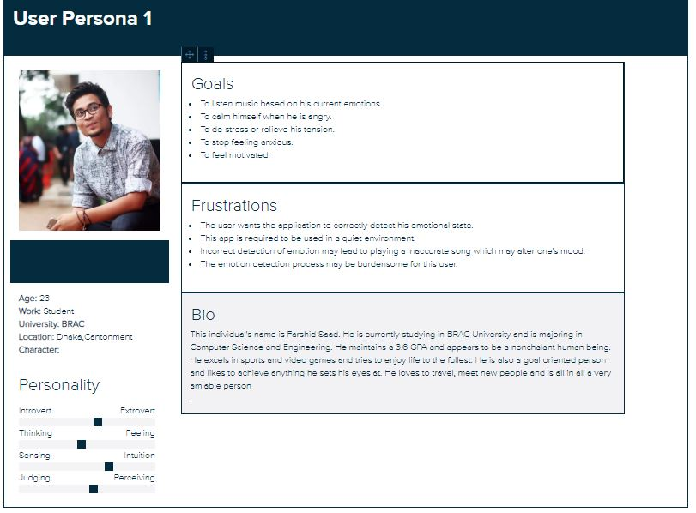

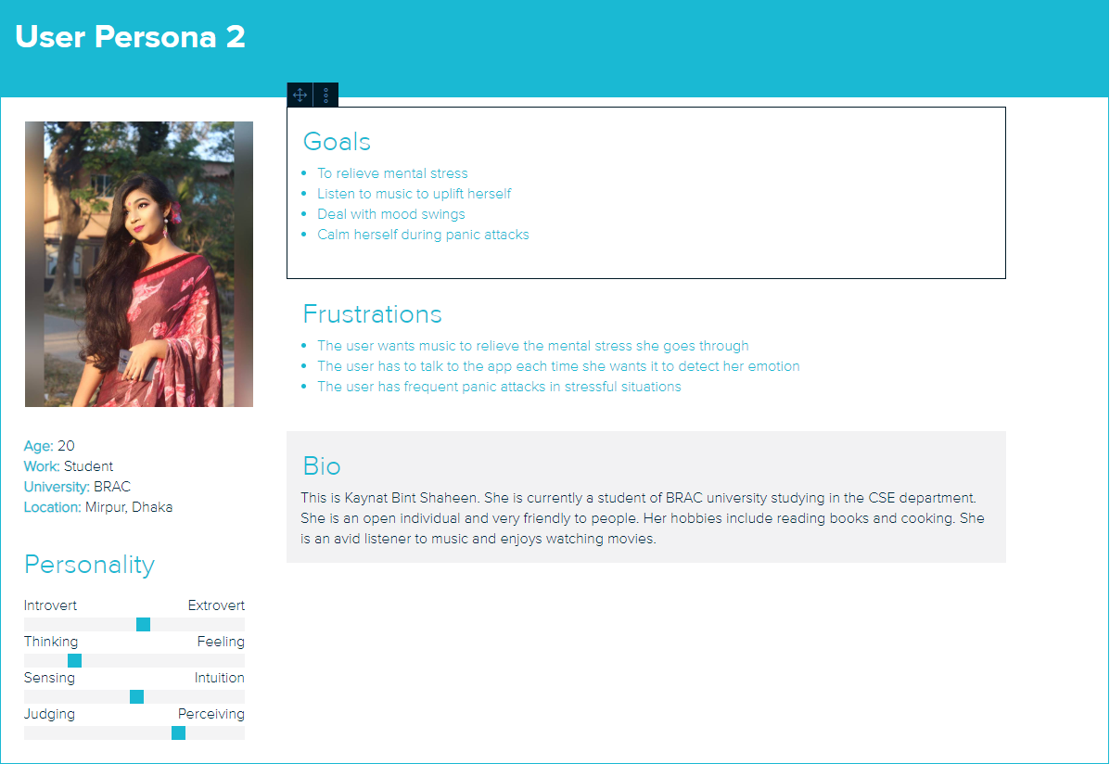

**Scenario:**

Below we represent 2 scenarios where our app can be used:

1. Farshid is a student of Computer Science and Engineering. School tests, exams, evaluations don’t necessarily go according to his expectations and desires. In such moments he needs some form of emotional assistance or some time alone. This is where our app comes to use. Our app can detect his emotions and play soothing music to relieve stress, tension and anxiety.
2. Kaynat is a student studying in the CSE department. She has been experiencing panic attacks and mood swings quite frequently. In such moments she should calm herself down to fight against the panic attack. Our app can be her solution as it will calm her down and help her focus

**Requirements:**

Our app will contain a series of questionnaires. A user will have to answer them by speaking to our app. The voice is thus detected and the emotional status of the user is detected. Accordingly, songs or playlists are presented to the user. The user may listen to a specific playlist or listen to the songs suggested by the app.

Here the user is supposed to talk to our app. This is because the emotional status of a user can be detected through the voice of the user. If the user as asked to type a response the correct emotions could not be extracted from the response text.

The functional requirements for our application covers the usability and user experience goals (UX). They are briefly discussed below:

1. **Usability Goals:**
   * Effectiveness: Our main goal for our app is to correctly recognize emotions and detect them. If this is achieved the user will be able to listen to music according to their emotions.
   * Safe to use: Our app will be very safe to use since we are not recording any personal data or preferences from the users.
   * Very good Utility: This app aims to provide the utmost user satisfaction and comfort. Thus we require to the correct songs according to the detected emotions.
   * Very good Learnability: Our app also will be easy to use. Thus our requirement is to make the interface as smooth as possible so that our users can easily learn how to use the app.
   * Very good Memorability: Our app has very good memorability. A user will be able to smoothly use the app after the first run.
2. **Emotional Requirements:**

Our app will ask several questionnaires to the users. According to the responses of the questionnaires our app will be able to detect the current emotional mood of the user and play an appropriate song. The user will feel relieved and emotionally uplifted. Thus our app can contribute to the emotional needs of the users.

1. **User experience goals:**
   1. Satisfying
   2. Enjoyable
   3. Pleasurable
   4. Helpful
   5. Entertaining
   6. Emotionally fulfilling

To achieve these particular user experience goals our app needs to have a friendly interface through which the user can interact with ease.

Our app has to correctly detect the emotions of the user to make it a happy and enjoyable experience for the user. The song selection also has to be done in such a way so that the user can feel emotionally relieved.

We are not storing the user information or what songs the user listened to previously. Each time the user uses the app a new set of questionnaires will appear and emotion will be detected again.